1. Create an interface polygon. In interface, create a method getArea with length and breadth as two parameters. Create a class Rectangle and find the area of Rectangle using getArea() function.

package Interface;

public interface Polygon {

abstract void getArea(int len, int bre);

}

package Interface;

class Rectangle implements Polygon

{

public void getArea(int len, int bre) {

System.out.println("The area of the rectangle is " + (len * bre));

}

public static void main(String[] args) {

Rectangle r1 = new Rectangle();

r1.getArea(10, 6);

}

}

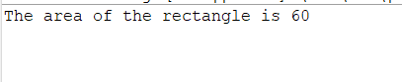

1. Write a program, where RBI will be an interface, have a method recurringDeposit which can accept the amount and duration. This must be implemented in class HDFC.
   1. When a customer deposit amount in HDFC, they must be able to know how much amount they will get after depositing for n period of time.
   2. Interest rate is defined in RBI interface.

package Interface;

public interface RBI {

public static final double intrest = 0;

abstract double recurringDeposit(double intrest);

}

package Interface;

import java.util.Scanner;

class HDFC implements RBI {

double deposits;

double time;

public double recurringDeposit(double intrest) {

Scanner sc = new Scanner(System.in);

System.out.println("Enter the amount you want to deposit");

deposits = (int) sc.nextDouble();

System.out.println("Enter the duration in months");

return time = (int) sc.nextDouble();

}

public static void main(String[] args) {

HDFC ri = new HDFC();

ri.recurringDeposit(intrest);

System.out.println("Final amount is : " + ri.deposits);

System.out.println("Your time period is : " + ri.time);

}

}

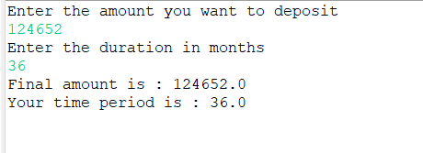

1. Create 2 interfaces. In the created interface, add 2 methods in same name. Create a new class and implement the interface. Check out the result(Multiple inheritance).

package Interface;

public interface A {

void aPuppy();

}

package Interface;

public interface B {

void aPuppy();

}

package Interface;

public class AB implements A, B {

public void a_Puppy() {

{

System.out.println("a Puppy");

}

}

public static void main(String[] args) {

AB Obj = new AB();

Obj.a_Puppy();

AB Obj2 = new AB();

Obj2.a_Puppy();

}

@Override

public void aPuppy() {

// TODO Auto-generated method stub

}

}

